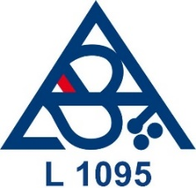
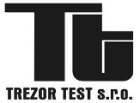
Accredited Testing Laboratory No. 1095
of the company TREZOR TEST s r.o.
Na Vršku 67, 250 67 Klecany, Czech Republic
Company Identification No.: 47544147
Tax Identification No.: CZ47544147

Application form No. with ATL/date
Application form No. with ACB/date
Application form No. with client
APPLICATION FORM FOR TESTS

Customer:  Address:  Identification number:  Tax Identification number: | Statutory representative:  Telephone:  E-mail:
Contact person:

Telephone:

E-mail:
Bank connection: | Account number:  Bank code:
Product identification:

Brand name of product:

Type of product (series):

Producer:

Producer's factory or product location:

Other information:

Required classification of product: | Requirement:
 | Standard:
Sample delivery date:
Sample Specifications:

By completing this application:
- The customer acknowledges that he has the opportunity to file his complaint against the activities of the ATL.

- The customer agrees to the processing of personal data in accordance with Regulation (EU) 2016/679 of the European Parliament and of the Council of 27 April 2016 on the protection of individuals with regard to the processing of personal data and on the free movement of such data.

- The customer agrees to carry out corrosion and temperature resistance tests in the premises of cooperating test laboratories.

Date:

_______________________________
Name / stamp and signature of customer

Records of ATL

Examination of the application  Fulfilled / NOT Fulfilled | Compliance with the applicant  Fulfilled / NOT Fulfilled | Valid accreditation  Fulfilled / NOT Fulfilled
Date:  Sign: | Date:  Sign: | Date:  Sign:

